Project Design Phase-II
Data Flow Diagram & User Stories

Date | 09-07-2026
Team ID
Project Name | ONLINE COMPLAINT REGISTRATION
Maximum Marks | 4 Marks

Data Flow Diagrams:
A Data Flow Diagram (DFD) is a traditional visual representation of the information flows within a system. A neat and clear DFD can depict the right amount of the system requirement graphically. It shows how data enters and leaves the system, what changes the information, and where data is stored.

ONLINE COMPLAINT REGISTRATION
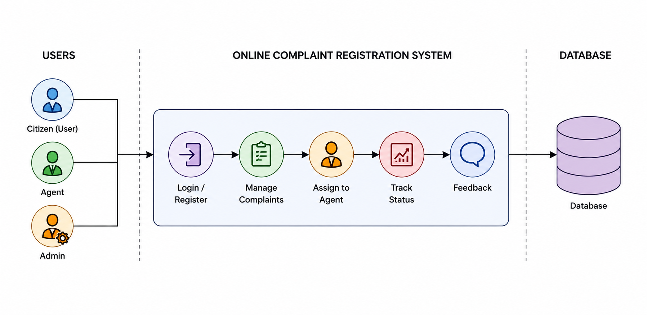
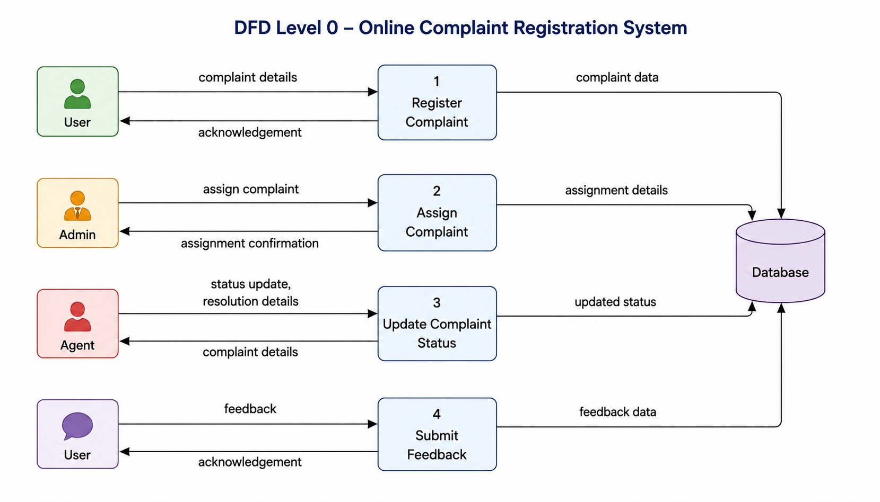

User Stories

User Type | Functional Requirement (Epic) | User Story Number | User Story / Task | Acceptance criteria | Priority | Release
Ordinary User | Registration | USN-1 | As an ordinary user, I can register using my name, email, phone number, password, and role. | User account is created successfully | High | Sprint-1
Ordinary User | Login | USN-2 | As an ordinary user, I can log into the system using valid credentials. | User is redirected to the dashboard. | High | Sprint-1
Ordinary User | Forgot Password | USN-3 | As an ordinary user, I can reset my password using my registered email address. | Password reset email is received successfully. | High | Sprint-1
Ordinary User | Complaint Registration | USN-4 | As an ordinary user, I can submit a complaint with category, description, and supporting image. | Complaint is stored successfully. | High | Sprint-2
Ordinary User | Complaint Tracking | USN-5 | As an ordinary user, I can view the current status of my complaint. | Complaint status is displayed correctly. | High | Sprint-2
Ordinary User | Chat | USN-6 | As an ordinary user, I can communicate with the assigned agent through chat. | Messages are sent and received successfully | Medium | Sprint-4
Ordinary User | Feedback | USN-7 | As an ordinary user, I can submit feedback after the complaint is resolved. | Feedback is stored successfully. | Medium | Sprint-4
Agent | Complaint Management | USN-8 | As an agent, I can view assigned complaints. | Assigned complaints are displayed. | High | Sprint-3
Agent | Status Update | USN-9 | As an agent, I can update complaint status and upload a resolution image. | Complaint status and resolution image are updated successfully | High | Sprint-4
Admin | User Management | USN-10 | As an administrator, I can manage users and approve agent accounts. | User and agent management functions work correctly. | High | Sprint-3
Admin | Complaint Assignment | USN-11 | As an administrator, I can assign complaints to available agents. | Complaint is assigned successfully. | High | Sprint-3
Admin | Dashboard | USN-12 | As an administrator, I can monitor complaints using dashboard statistics. | Dashboard displays complaint statistics correctly. | Medium | Sprint-4

